1. Install Docker, either on your native OS or on a VM. Make sure it runs. Type "docker -v" to check if it's installed.

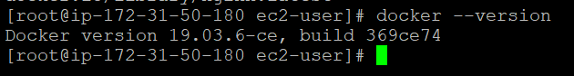

1. Find a image from dockerhub of your choice(recommeded: nginx), don't use browser, pull the official image from dockerhub

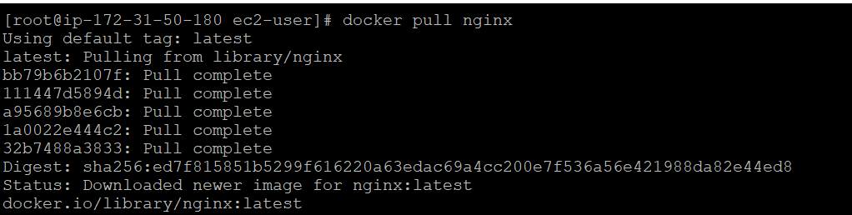

1. List all the available images in your machine/vm, make sure you see recently pulled image in the list.

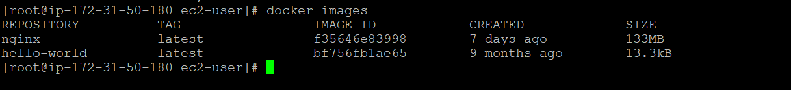

1. Find out the "Full" ImageId of the image that you pulled and write it below.

docker images --format "{{.ID}}



1. Create a container of your image

docker run --name mynginx1 -p 80:80 -d nginx

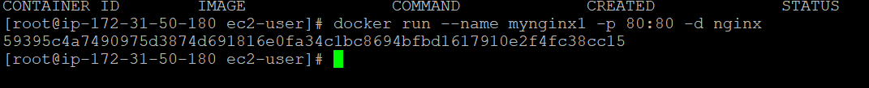

1. List all the running containers

docker ps

1. List all the running and stopped containers

Docker ps –a

8. Find out the "Full" containerId of the container and write it below.